

**A**

**PROJECT REPORT**

**ON**

**“Project Title”**

**SUBMITTED BY**

“Miss. Akanksha Balaji Bochare”

**UNDER GUIDENCE**

“Prof. Madhuri Dhavan ”

**SUBMITTED TO**

**Savitribai Phule Pune University**

**AS A PARTIAL FULLFILLMENT**

**FOR THE AWARD OF THE DEGREE**

**Bachelor of Business Administration**

**(Computer Application)**

**BBA(CA)**

**THROUGH THE PRINCIPAL**

**ASM’s**

**College Of Commerce, Science and Information Technology,**

**Pimpri, Pune-18**

**(Academic Year 2023-24)**

**CERTIFICATE**

This is to certify that  **Miss. Akanksha Balaji Bochare** are students of SYBBA(CA) SEM-IV course have satisfactorily completed the project report entitled as **AgroMart- Online Fertilizer Shopping Site** in the partial Fulfilment of Bachelor of Business Administration (Computer Application) course during the academic year 2023-2024.

Project Guide Principal

Internal Examiner External Examiner

**ACKNOWLEDGMENT**

We would like to thank the people who helped us in completion of this project and with deep content and pleasure we express our gratitude toward those people who have given us their precious time and guidance in developing project.

It’s our privilege to express our sincere thanks and demo sense of gratitude to our guide Prof. Madhuri Dhavan for imparting us valuable guidance during the preparation of these papers. She helped us by suggesting us many references of emerge out with a perfect presentation.

Thanking You.

Sincerely

Mr. Sandip Ban

Miss. Akanksha Bochare

**DECLARATION**

I undersigned **“ Miss.Akanksha Balaji Bochare”** hereby declare that the project work entitled **“AgroMart- Online Fertilizers Shopping Site”** is conducted under the guidance of **“Prof. Madhuri Dhavan Mam”**. It is our original work and has not been copied from any other source or project work submitted to the University.

**Date:**

**(“Miss.**  **Akanksha Bochare”)**

|  |  |  |
| --- | --- | --- |
| **INDEX** | | |
| **Sr. No.** | **Contents** | **Page Number** |
| **1** | **Introduction** | **6** |
|  | **1.1 Motivation** | **7** |
|  | **1.2 Goals and Objectives** | **7** |
| **2** | **System Analysis** |  |
|  | **2.1 Existing System** | **8** |
| **2.2Scope and Limitation of Existing System** | **8** |
| **2.3Proposed System** | **10** |
| **2.4 Feasibility Study** | **10** |
| **3** | **Diagrams** |  |
|  | **3.1 ER Diagram** | **15** |
| **3.2 DFD(Level 0,1)** | **16** |
| **4** | **Implementation Details** |  |
|  | **4.1 Hardware Specification** | **18** |
| **4.2 Software Specification** | **18** |
| **5** | **Data Dictionary (DATABASE)** | **18** |
| **6** | **System Design** |  |
|  | **Input And Output Screen** | **22** |
| **7** | **Testing** | **28** |
| **8** | **Conclusion** | **31** |
| **9** | **Future Enhancement** | **31** |
| **10** | **Bibliography And References** | **32** |

**INTRODUCTION**

This is a project report that describes the development of an online shopping website using PHP and MySQL. The website allows customers to browse, search, and purchase products from various categories. The website also has an admin panel that manages the inventory, orders, and customers. The project report includes the system requirements, design, implementation, and testing of the website.

This is a web-based site that aims to connect customers and retailers directly, without the involvement of middlemen. The website is developed using HTML,CSS,JavaScript ,Bootstrap and has various features for users.

This project is designed to be used by customers for shopping the fertilizers and other related products. It is an online system through which customers can create their accounts on site, register themselves on website, view available products and order or add the products in the cart.

The aim of this project is to develop an online platform that allows customers to buy various types of organic fertilizers, organic seeds . The website allows customers to browse, search, and purchase products from various categories.

**MOTIVATION**

Creating an online fertilizer shopping site project is a fantastic way to apply your programming knowledge and skills to a real world scenario. Not you will learn only about designing user friendly interfaces but you will also contribute to making shopping processes smoother for farmers. Plus project can showcase your abilities to potential employers or clients,making it a win-win situation! The online fertilizer shopping site is a web site designed to facilitate the process of shopping fertilizers and seeds online. The system provides users to search for available products, add them to cart, manage orders, and handle payments . With features such as user registration, product availability checking and payment site aims to streamline the shopping process for both customers and sellers. By leveraging modern web technologies, site offers a user-friendly interface and efficient functionality to enhance overall shopping experience.

**GOALS AND OBJECTIVES**

The purpose objective of the shopping site is to provide a convenient platform for users to shop fertilizers online.

* To provide a convenient and reliable online platform for customers to buy fertilizers for their agricultural needs.
* To increase the accessibility and availability of fertilizers for customers across different regions and locations.
* To reduce the cost and time involved in buying fertilizers from offline sources.
* To enhance the customer satisfaction and loyalty by offering high-quality products and services.
* To contribute to the growth and development of the online fertilizers industry and the agricultural sector.

**EXISTING SYSTEM**

Creating an online shopping site for organic fertilizers involves several key components to ensure smooth functioning and user satisfaction. Here's a breakdown of the existing system for such a platform:

1. User Interface: The website have user-friendly interface that allows customers to easily navigate through different categories such as organic fertilizers, organic seeds ,view product details, and make purchases

2. Product Listings: Each product listing include detailed descriptions, images, pricing.

3. Search Functionality: Searvh feature helps to search for products that user needs.

4. Shopping Cart and Checkout: Users are able to add desired products to their shopping cart, review their selections, and proceed to checkout seamlessly.

5. Account Management: users can create accounts, register themselves , they can login to the website , they can view their profile ,update and delete their profile. Users can also see their order history and they can logout from site. Guest checkout is also available for users who prefer not to register.

6. Order Management: admin can manage orders efficiently, including order processing, total orders sold, order status updates, and order completion .

7. Customer Support: we have added contact facility where customers can reach out us for their issues.

**SCOPE AND LIMITATION OF EXISTING SYSTEM**

The scope and limitations of the existing system for an online organic fertilizers shopping site define what the platform can accomplish and where it falls short.

Scope:

Product Variety: The platform offers a wide range of organic products suitable for different types of plants and gardening needs.

Convenience: Customers can easily search for products, add them to their shopping carts and order them with cash on delivery mode

Information Availability: Detailed product descriptions, images, are provided to help users make informed purchasing decisions.

Customer Support: Customers can reach us out as we have provided contact information

Order Management: Efficient order processing, order management, are in place to manage orders effectively

**Limitations:**

Limited Product Selection: While the platform strives to offer a diverse range of organic fertilizers, there may be limitations in terms of product availability, especially for niche or specialized products that are not widely distributed.

Geographical Constraints: Shipping restrictions or limited delivery coverage may hinder access to the platform for customers in certain regions, potentially excluding them from the benefits of online shopping for organic fertilizers.

Technical Issues: The website may encounter technical glitches, downtime, or performance issues, impacting the user experience and potentially leading to frustration or abandonment of the shopping process.

Lack of Personalization: The platform may lack advanced personalization features such as tailored product recommendations based on user preferences or past purchase history, potentially limiting its ability to cater to individual customer needs effectively.

Regulatory Compliance Challenges: Ensuring compliance with evolving regulations and certifications for organic products can be challenging, and the platform may face obstacles in verifying the authenticity and quality of all products listed.

Competitive Landscape: The platform operates within a competitive market, facing competition from other online retailers, local garden centers, and traditional brick-and-mortar stores selling organic fertilizers, which may impact its market share and profitability.

**PROPOSED SYSTEM**

A proposed system refers to a conceptual plan or design for a new software, application, or technology solution that addresses a specific problem or fulfills a particular need. It outlines the key features, functionalities, and components of the system before it is developed and implemented.

We designed this project to shop organic fertilizers and organic fruits and vegetable seeds . User can browse , search and add products to cart . in order to shop or place order they need to login and after that they can checkout . if user don’t have an account they can register themselves with us and then they can login to shop products . in my account section they can view their profile , edit their profile , view order history, if they have any item in their cart they can see the pending orders .To place the order user should be logged in then he should add items to the cart , after clicking on cart they will go to cart page , there they can click on checkout then they can select payment mode as of now only cash on delivery available after clicking on cash on delivery they will get pop up orders submitted successfully . if they want to quit they can logout or if wanted they can delete their account.

At admin side all the authorities are given to admin only as of now no staff or other members are involved . If admin don’t have an account they can register and login on website. Only admin can insert products , view products , edit the products, and delete the products . Admin can add or remove or delete categories and same for delivery partners . he can view total products sold , total users of website and payments for every order And if wants to sign out he can logout from website .

**FEASIBILITY STUDY**

This project is designed to be used by customers for shopping the organic products. It is an online system through which customers can create their accounts on site, register themselves on website, view available products and order the products.

The aim of this project is to develop an online platform that allows customers to buy organic fertilizers and seed for their needs. The website allows customers to browse, search, and purchase products from various categories.

**\*Market analysis**

1.DEmand analysis :

There’s a growing need to boost agricultural production and increased awareness of the detrimental effects of chemical inputs and the positive effects of organic fertilizers. As more individuals opt to eat organic food, there is a rise in demand for organic agriculture practices. In regions like Europe where organic farming is widely appreciated, there is a significant need for organic fertilizers on a global . Dry organic fertilizers have a huge market opportunity due to the increasing demand for organic foods and services

2.Competitive analysis: Market Leaders: Some of the major players in the organic fertilizer market include Tata Chemicals Limited, The Scotts Miracle-Gro Company, Coromandel International Limited, National Fertilizers Limited, Krishak Bharati Cooperative Limited, Midwestern BioAg, Italpollina SpA, ILSA S.p.A, Perfect Blend Biotic Fertilizers, Sustane Natural Fertilizer Inc., BioStar Systems LLC, AgroCare Canada Inc., and Nature Safe1. These companies have a strong presence in the market and offer a variety of organic fertilizers.

3.Swot analysis:

Strengths: Niche Market: Organic fertilizers and seeds cater to a specific market of consumers who are environmentally conscious and prefer organic products.Eco-friendly: Organic fertilizers and seeds are environmentally friendly, which can be a major selling point for consumers concerned about the environment. Health Benefits: Organic fertilizers are safer for the soil, plants, and consumers as they do not contain harmful chemicals.

Weaknesses:

Limited Awareness: There might be limited awareness among consumers about the benefits of organic fertilizers and seeds.

Pricing: Organic fertilizers and seeds can be more expensive than synthetic ones, which might deter cost-sensitive customers.

Supply Chain: Ensuring a consistent supply of organic materials to produce the fertilizers can be challenging.

Opportunities:

Growing Market: The global market for organic fertilizers is expected to grow at a CAGR of 6.3% between 2022 and 20321. This presents a significant opportunity for growth.

Increasing Demand: As more individuals opt to eat organic food, there is a rise in demand for organic agriculture practices.

Supportive Policies: Supportive government policies and increasing demand for sustainable agriculture can provide opportunities for expansion.

Threats:

Competition: There is stiff competition from major players in the organic fertilizer market like Tata Chemicals Limited, The Scotts Miracle-Gro Company, Coromandel International Limited, etc4.

Climate Change: Unpredictable weather patterns due to climate change can pose a threat to the production of organic fertilizers2.

Perception: Some farmers may feel obligated to use chemical fertilizers in addition to organic ones to maximize their agricultural output

**TECHNICAL FEASIBILITY=**

Website Development: With the use of technologies in web development , creating an e-commerce website for selling organic fertilizers is technically feasible.here we used HTML,CSS,Javascript ,bootstrap,PHP and MySQL to build the website.

User Interface and Experience: The website is user-friendly and easy to navigate.

Maintenance and Support: As of now only admin will be there for Ongoing technical support and maintenance to ensure the smooth operation of the website, handle updates, and fix any issues.

ECONOMIC FEASIBILITY

Economic feasibility refers to the cost-effectiveness of a proposed project and whether it is financially viable. Here’s a general economic feasibility analysis for a small level organic fertilizer shopping site:

Initial Investment: The initial investment would include the cost of setting up the website, inventory procurement, payment gateway integration, and marketing efforts. The cost can vary based on the specific requirements of the shopping site.

Operating Costs: These include the cost of maintaining the website, inventory management, shipping, and customer service. There would also be ongoing marketing costs.

Revenue Streams: The primary revenue stream would be the sales of organic fertilizers and seeds. Additional revenue streams could include advertising revenue if you decide to display ads on your site, or commission from selling related products.

Profitability: The profitability would depend on the price of the organic fertilizers,seeds, the volume of sales, and the operating costs. According to a market study, the global market for Organic fertilizers is expected to reach US$ 9,248.6 Mn in 2022 and grow at a CAGR of 6.3% between 2022 and 2032. This indicates a growing market and potential for profitability.

Return on Investment (ROI): The ROI would depend on the initial investment, the net profit, and the time frame considered. It’s important to do a detailed financial analysis to estimate the ROI.

**LEGAL AND REGULATORY COMPLIANCE=**

Local Government Permission: We will need to obtain permission from our local government, which may include the city, district , and other small-scale regulatory bodies where we r starting our project.

State Government Permission: In addition to the local government, we should obtain permission from our individual state, which may have restrictions that you must apply for1.

Fertilizer Store License: The method of decomposition produces fumes and by-products that might contaminate drinks. Contamination will continue to spread to fish, plants, and animals in the surrounding region. Because improperly stored fertilizer may quickly pollute whole ecosystems, each state has its own storage rules1.

Organic Certification: If you’re selling organic fertilizers, you need to comply with the Food Safety and Standards (Organic Foods) Regulations, 2017 in India2. The organic food offered or promoted for sale shall also comply with all the applicable provisions of one of the following systems, namely: National Programme for Organic Production (NPOP); Participatory Guarantee System for India (PGS-India)2.

Import Regulations: when we wre importing organic fertilizers, we need to ensure that there is equivalence of standards between National Programme for Organic Production (NPOP) and the organic standards of the respective exporting countries

**Operational feasibility**

Process: The process would involve setting up the website, procuring inventory, managing orders, shipping, and customer service. The end-users’ acceptance of the new process is crucial1.

Resources: Resources would include the website platform, inventory, shipping and delivery mechanisms, and customer service personnel. You would need to evaluate whether you have access to these resources.

People: we will need people to manage the website, handle inventory, manage orders, provide customer service, and carry out marketing activities. You would need to evaluate whether we have the necessary manpower and skills1.

Change Management: Any new process would involve change, and you would need to manage change resistance from within the organization and from customers. You would need to have a plan to handle this resistance1.

Implementation: You would need to have a detailed implementation plan that includes tasks, timelines, responsibilities, and review mechanisms1.

**ER-Diagram**

# 

**Data flow diagram level 0**

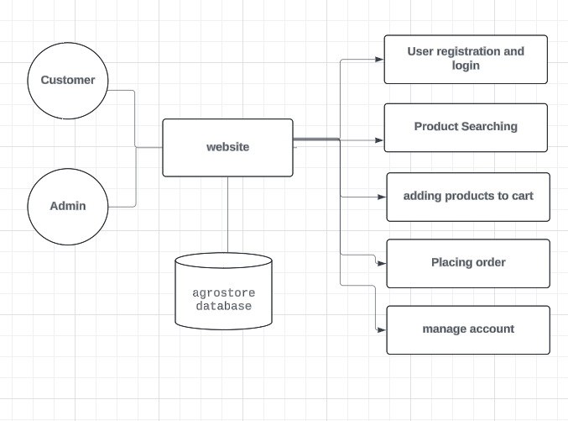

**Data flow diagram level 1**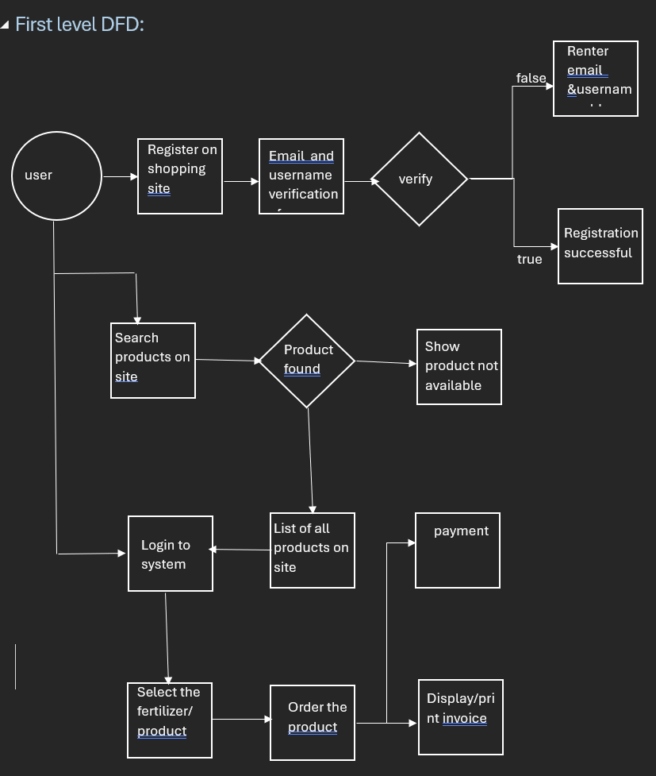

**IMPLEMENTATION DETAILS**

**HARDWARE SPECIFICATION:**

Laptop Lenovo IPG3

AMD Ryzen-5 11th Gen.

Hard Disk 512GB SSD NVMe.

Printer.

**SOFTWARE SPECIFICATION:**

Operating System: Windows 11.

Front-end: HTML, CSS, JS, Bootstrap

Back-end: PHP, MySQL.

**DATA DICTIONARY (DATABASE)**

**User details = `usertable`**

|  |  |  |  |
| --- | --- | --- | --- |
| **Field_Name** | **Data_Type** | **Constraint** | **Description** |
| user_id | int | PRIMARY KEY | USER ID |
| user_name | varchar | NOT NULL | Usser name |
| user_email | varchar | NOT NULL | email |
| user_password | varchar | NOT NULL | password |
| user_image | varchar | NOT NULL | User image |
| user_ip | varchar | NOT NULL | Ip adress |
| user_address | varchar | NOT NULL | Address |
| user_mobile | varchar | NOT NULL | Mobile no |

**Admin details:`admin_table`**

|  |  |  |  |
| --- | --- | --- | --- |
| **Field_Name** | **Data_Type** | **Constraint** | **Description** |
| admin_id | int | PRIMARY KEY | Admin ID |
| admin_name | varchar | NOT NULL | Admin name |
| admin_email | varchar | NOT NULL | email |
| admin_password | varchar | NOT NULL | password |

**cart details:`cart_details`**

|  |  |  |  |
| --- | --- | --- | --- |
| **Field_Name** | **Data_Type** | **Constraint** | **Description** |
| product_id | int | PRIMARY KEY | Product ID |
| ip_address | varchar | NOT NULL | Ip address |
| quantity | varchar | NOT NULL | quantity |

**Category details:`categories`**

|  |  |  |  |
| --- | --- | --- | --- |
| **Field_Name** | **Data_Type** | **Constraint** | **Description** |
| category_id | int | PRIMARY KEY | Category id |
| category_title | varchar | NOT NULL | category_title |

**Delivery partner details:`delivery`**

|  |  |  |  |
| --- | --- | --- | --- |
| **Field_Name** | **Data_Type** | **Constraint** | **Description** |
| delivery_id | int | PRIMARY KEY | delivery id |
| delivery_title | varchar | NOT NULL | Delivery title |

**Pending orders details:`orders_pending`**

|  |  |  |  |
| --- | --- | --- | --- |
| **Field_Name** | **Data_Type** | **Constraint** | **Description** |
| order_id | int | PRIMARY KEY | Order id |
| user_id | int | NOT NULL | user_id |
| invoice_number | int | NOT NULL | Invoice number |
| product_id | int | NOT NULL | Product id |
| quantity | int | NOT NULL | Quantity |
| order_status | varchar | NOT NULL | Order status |

**Products details:`products`**

|  |  |  |  |
| --- | --- | --- | --- |
| **Field_Name** | **Data_Type** | **Constraint** | **Description** |
| product_id | int | PRIMARY KEY | Product id |
| product_title | varchar | NOT NULL | Product title |
| product_description | varchar | NOT NULL | Product description |
| product_keywords | varchar | NOT NULL | Product keywords |
| category_id | int | NOT NULL | category id |
| delivery_id | int | NOT NULL | Delivery id |
| product_image1 | varchar | NOT NULL | Product_image1 |
| product_image2 | varchar | NOT NULL | Product_image2 |
| product_image3 | varchar | NOT NULL | Product_image3 |
| product_price | varchar | NOT NULL | product_price |
| date | timestamp | NOT NULL | Date |
| Status | varchar | NOT NULL | Status |

**User orders details:`user_orders`**

|  |  |  |  |
| --- | --- | --- | --- |
| **Field_Name** | **Data_Type** | **Constraint** | **Description** |
| order_id | int | PRIMARY KEY | Order id |
| user_id | int | NOT NULL | User id |
| amount_due | int | NOT NULL | Amount due |
| Invoice_number | int | NOT NULL | Invoice number |
| total_products | int | NOT NULL | Total products |
| Order_date | timestamp | NOT NULL | Order date |
| order_status | varchar | NOT NULL | Order status |

**User payments details:`user_payments`**

|  |  |  |  |
| --- | --- | --- | --- |
| **Field_Name** | **Data_Type** | **Constraint** | **Description** |
| payment_id | int | PRIMARY KEY | Payment_id |
| order_id | int | NOT NULL | Order id |
| Invoice_number | int | NOT NULL | Invoice number |
| amount | int | NOT NULL | amount |
| payment_mode | varchar | NOT NULL | Payment mode |
| date | timestamp | NOT NULL | date |

**SYSTEM DESIGN**

**INPUT SNAPSHOTS:**

**User Login page:**

**Registration page:**

**Admin login**

**OUTPUT SNAPSHOTS:**

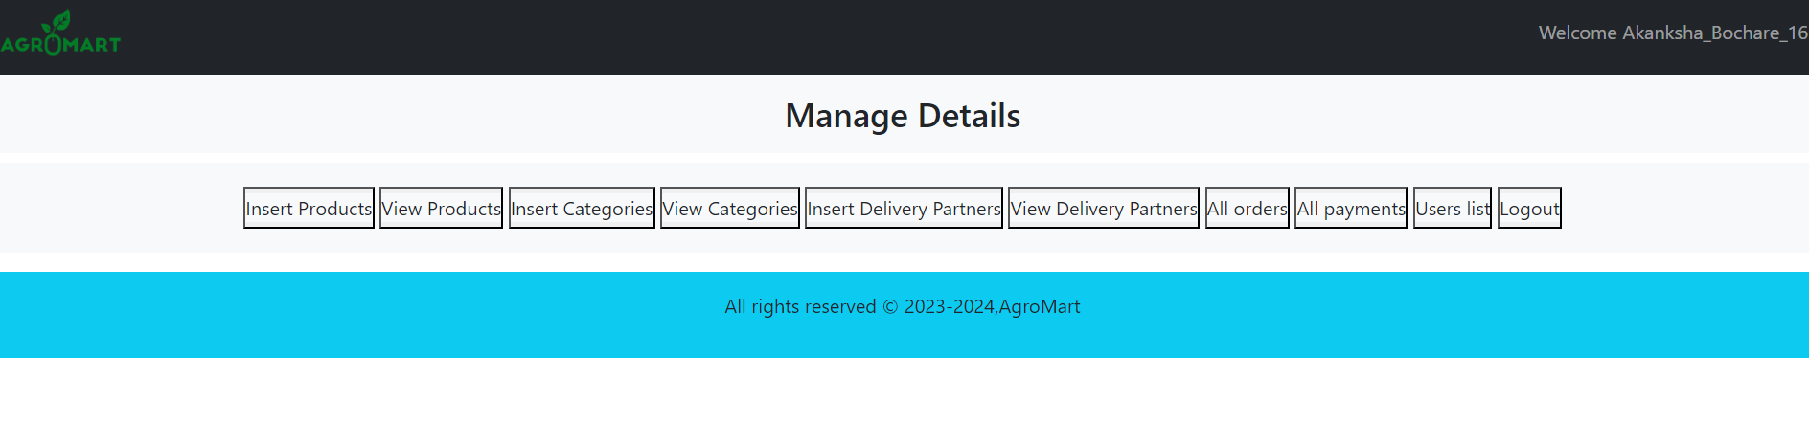**Admin Dashboard:**

**Homepage :**

**My account:**

**Insert products :**

**

**

**

****All orders :**

**TESTING**

**Black Box Testing:**

Black box testing focuses on testing the functionality of a system without knowledge of its internal code or structure. Here's how black box testing can be applied to an organic fertilizer shopping site:

User Registration:Tested the user registration process by providing valid and invalid input data. By valid data we get popup registered successfully and with invalid data gets popup of fill the mandatory fields .Verified that users can successfully register with unique usernames and valid email addresses. Users can register themselves with same username and email once only

User Login:Tested the user login process with valid and invalid credentials.Verified that registered users can log in successfully and access their accounts.

Product Browsing:Tested product browsing by searching for specific items and navigating through different categories.Verifed that product listings display accurate information such as product names, descriptions, prices, and images.

Cart Management:Tested adding and removing items from the shopping cart.Verified that the cart updates dynamically when items are added or removed.Tested the checkout process, ensuring that users can proceed to payment without encountering errors.

User Account Management:Tested updating user profile information such as address and contact details.Verified that users can change their passwords and update their preferences.Tested account deletion functionality, ensuring that users can delete their accounts if desired.

.

Usability Testing:Evaluated the user interface for clarity, and ease of use.Tested navigation flows to ensure users can find what they're looking for quickly and efficiently.Verifed that interactive elements such as buttons, links, and forms behave as expected..

**White Box Testing:**

White box testing, also known as structural testing or glass box testing, involves testing the internal workings of a system, including its code, algorithms, and data structures. Here's how white box testing can be applied to an organic fertilizer shopping site:

User Registration:Tested the registration form validation by examining the code to ensure that input fields are properly validated for length, format, and uniqueness.Verifed that the registration process triggers the appropriate database insertions and that user passwords are securely hashed.

User Authentication:Tested the login process by examining the code to verify that user credentials are correctly compared with stored hashes.

Product Management:Tested the backend functionality for adding, editing, and deleting products by reviewing the code for these operations.Verifed that product details are stored correctly in the database and that images are uploaded and linked properly.

Cart Functionality:Tested the code responsible for adding, updating, and removing items from the shopping cart.Verified that the cart total is calculated accurately and that the correct items are displayed in the cart.

Database Operations:Tested database interactions by reviewing SQL queries to ensure they are properly constructed and working properly.

**CONCLUSION**

In conclusion, the AgroMart - Online Fertilizer Shopping Site project represents a significant milestone in leveraging technology to revolutionize the agricultural industry. By providing farmers and gardeners with easy access to high-quality organic products, we aim to contribute to sustainable farming practices and environmental conservation. With ongoing support and future enhancements, we are committed to further improving the platform and delivering value to our users and stakeholders.

**FUTURE ENHANCEMENTS**

Product Reviews and Ratings: we will Allow customers to leave reviews and ratings for products they have purchased. This feature can help build trust and credibility among users and assist future buyers in making informed decisions.

Advanced Search Filters:we will Enhance the search functionality by adding advanced filters such as price range, brand, product type, and customer ratings. This will help users narrow down their search results and find products more efficiently.

Product Recommendations: We will Implement a recommendation system based on user browsing history, purchase patterns, and preferences. This personalized feature can suggest relevant products to users, increasing engagement and sales.

Social Media Integration: We will Enable users to share their favorite products or purchases on social media platforms like Facebook, Twitter, and Instagram. This can help increase brand visibility and attract new customers through word-of-mouth marketing.Customer Feedback Form: Create a feedback form or survey to gather insights and suggestions from customers. Use this feedback to identify areas for improvement and implement changes to enhance the overall user experience.

**BIBLIOGRAPHY AND REFERENCES**

**BOOKS :**

PHP O’Reilly

Nirali Prakashan

**REFERENCES**:

<https://www.w3schools.com>

<https://getbootstrap.com>

https://www.lucidchart.com

<https://www.tutorialspoint.com>

<https://www.javatpoint.com>